





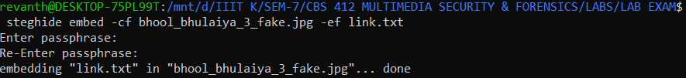

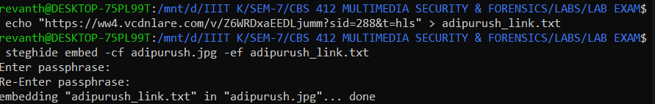

(movielover)

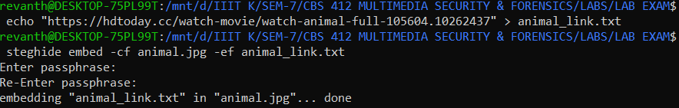

(content)

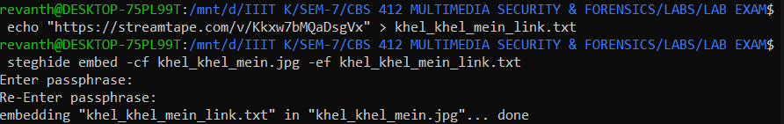

(movielover)

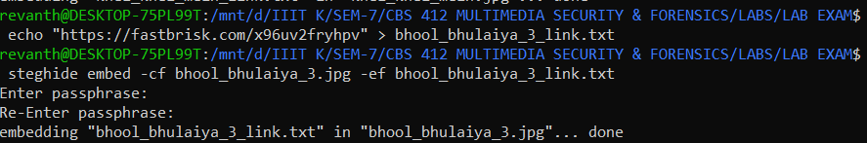

(content)

